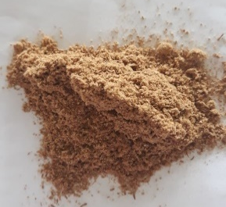
Figure 1. Kepel seeds powder
(a)
(b)
Figure 2. FTIR graph of flavonoid cmpound (a) 1 hr extraction (b) 2 hr extraction

Table 1. Flavonoid compound of extracted kepel seeds
Ethanol (%) | Yield (%)
 | 1 hr | 2 hr
10 | 18.4 | 19.2
30 | 14.2 | 14.6
50 | 13.4 | 7.8
70 | 4 | 4
90 | 3.6 | 2.2

Figure 3. Total flavonoid of kepel seeds in the variation of ethanol concentration

Table 2. Water content of flavonoid encapsulation
Ethanol (%) | Water content (%)
 | 1 hr | 2 hr
10 | 8.91 | 5.26
30 | 8.97 | 7.59
50 | 6.94 | 7.14
70 | 4.76 | 4.76
90 | 5.26 | 8.33

