Empirical Investigation on the Relationship between Exports and economic Growth; in selected LDCs country Groups (1988-2018)

Khalil Ghazi Hassan

University of Duhok, Iraq, e-mail: Khalil.ghazi@uod.ac

Abstract

This study re-examines the export-led growth hypothesis for the two developing country groups i.e. the Middle East and North Africa (MENA) and, South Asia (SA) countries. Using time series data for the period of (1990-2018), Standard time series procedures of unit root testing via (ADF, PP) tests, cointegration, error correction modelling and Granger causality tests are utilized. Evidence for long-run cointegration relationships between the exports and economic growth in both cases was found. However, there is no evidence for significant relations between them. Furthermore, there is no Granger causality between economic growth and exports in the two directions for the MENA countries. But for the SA countries, we note a unidirectional causality from economic growth to exports, i.e. the growth in both country groups was not driven by an export-led growth strategy. This implies that exports aren’t the cause of output growth.

Key words: Exports, Economic Growth, Causality, Middle East, South Asia

JEL Codes: F10, F43

Introduction

Classical and neo-classical economists believe that the contribution to international trade can have a positive influence on economic growth. meanwhile many arguments support the belief that exports directly lead to greater economic growth because they contribute to the accumulation of foreign exchange, facilitating the dissemination of knowledge and increasing input efficiency. Thus, the pace of growth, In the event of any of these three cases, they can be described as the "growth engine" (James R., 2016). Furthermore, export expansion will influence economic growth by generating positive earnings on other economic activities via more professional administration styles, improved manufacturing techniques and economies of scale (Ghatak S. & Price S.W., 1997).
Efforts focused on studying and analyzing the links between export increase and economic growth, explaining the causes of this phenomenon, and conducting several empirical studies to test the hypothesis in different countries of the world. The export-led growth hypothesis, as a statute, is supported by the following arguments. First, within international trade multiplier, export growth increases production and employment. Second, the foreign exchange provided by export helps import capital goods, which in turn increases the production possibilities. Third, it contributes to expanding markets, competition, economies of scale and acceleration of technical progress in production. Finally, these theoretical arguments explain the strong relationship between export and production growth and are empirical evidence in favor of the hypothesis(Kugler P., 1991).
Discussions focused on the role of exports in enhancing economic growth. (Bhagwati, 1988)and (Balassa, 1978) and others pointed to the obvious positive impact of exports on economic growth. The export-based growth hypothesis discussed by (ELG), (Tyler W.G., 1980) and(Sen S., 2012), followed by several studies that indicated the importance of exports in generating growth (Hallaert J.J. , 2006) and numerous empirical studies have found that rapid export growth accelerates economic growth(Matsane S.H., 2010).
This study attempts to examine the export-led growth hypothesis in two groups of developing countries, namely the (MENA) and (SA) countries. It also determines the trend of the causal relationship between the underlying variables during the period of 1988-2018. The parameters of the variables are expected to be positive and have a significant impact on GDP growth. The expected positive sign of the export variable is derived from the assumption that the export sector produces external factors leading to increased production in other sectors.
The final aim of this study is to estimate and analyze the impact of exports in the economic performance in underlying country groups. So, the importance of the study comes from the fact that such results can explain the effects of export promote policies, and in particular the importance of the export sector and its performance on the rate of growth, and because the inclusion of the mentioned variables helps to empirically examine the links between them.
The first section presents the theoretical framework and presents a review of previous literature on the links between exports and economic growth. The second section will discuss the methodology and data utilized. The results are discussed in section three and, section four summarizes the conclusions.

Theoretical framework and literature review

Trade theory claims that exports boost the local economy through several channels. The increase in exports promote real production and encourages local companies to specialize in the production of export goods, leading to an increase in productivity. Also, more skilled labor is used in the country's export sector. As a result of these developments, the industry will be divided into two groups as a more productive and inefficient non-commercial sector. According to (Gokmenoglu, Sehnaz, & Taspinar, 2015) exports can be seen as an engine of growth in three ways(Ben-david D. & Loewy M., 2018); firstly ,as an element of total production, an increase in the demand for domestic exports can promote production growth, increasing employment and income in the exportable sector. Secondly, export growth can indirectly affect growth through effective resource allocation, efficient use of capacity, exploitation of economies of scale, and catalyzing technological improvement due to competition in overseas markets(Loewy, 2008).
Thirdly, exports can provide foreign currencies that allow for increased levels of capital and intermediate goods imports, which in turn stimulate the capital formation and thus stimulate production growth (Rizavi S.S. et al, 2010). According to Nasser and Manouchehr (2000), export-oriented policies contribute to economic growth through various summarized methods (Abdulnasser H. A.& Manouchehr I.,2000):
• The Keynesian hypothesis that increased exports and through the multiplier of foreign trade leads to the expansion of production.
• Exportation provides foreign currency to allow increased imports of capital goods and intermediate goods, which leads to economic growth.
• Exports increase efficiency through competition.
• Competition prompt economic activity diffusion of technology defined in production, which is an important potential source of growth.

Literature review:

(Balassa, 1985) noted that gains from trade would be greater in economic growth if the export promotion strategy was followed, as this strategy ensured more efficient use of productive resources. Similarly, (Ibrahim M.H., 2002) found that Real GDP, exports, and imports are to be cointegrated and that Granger causality runs from exports and imports to real output. (Baharumshah A.Z. & Rashid S., 1999) results approve that economic growth causes export growth for industrial exports. (Hamori, 2003) studied the effects of trade on growth in four African countries. The results indicated a different way of causality and non-causality between exports and growth among (OECD) countries.
According to (Furuoka F., 2007), outcomes do not support the “export-led growth” hypothesis. Rather, there exists a mutually reinforcing long-run relationship between exports and economic growth, and also detected unidirectional causality from economic growth to exports. (Narayan, 2007) found evidence supporting the export-led growth hypothesis in the long-run. (Rizavi S.S., 2010) shows that openness played an effective role in the output growth of SA countries during 1980-2008. (Abbas S., 2012) results show that causality runs only from GDP to exports in both the short and long-run periods. The result indicates that both in the short and long run only growth in production cause exports growth. (Ronit M., 2014) used a three-step procedure of first conducting a Vector Auto Regression (VAR) analysis followed by a Granger Causality Test and an Impulse Response Function. He found a consistent VAR Results; Furthermore, the Granger Causality Test determines that economic Growth causes export growth. Finally, there are much higher responses to export through a change in economic growth.(Saaed A.A. & Hussain M.A., 2015) findings indicate a two direction causality between exports and imports and between exports and economic growth. These outcomes offer evidence that growth in Tunisia was forced by a growth -led import strategy as well as export-led import.
The study by ( Huang J. & Ramirez M.D., 2016) shows that Exports encourage output growth in three of the four countries that have cointegrated data, which ensures the exports-led growth hypothesis found in some of the extant literature. There was no cointegration because the variables are stable at dissimilar orders from I(0) to I(2). (Sayef B., 2017) defined that there is a unidirectional causality between imports and economic growth. In addition to that, the results show that there is no causality relations between exports and output growth. (Ikram S. et al, 2018) conducted a study to obtain evidence on the relationship between export, import, and economic growth. He finds a cointegration relationship between economic growth, exports, and imports. Results also indicated that the causality runs from GDP to exports.
The results of (Samad A. 2019) find bidirectional causality running from GDP to export in Malaysia, Singapore and Thailand. Unidirectional causality found in Bangladesh, Pakistan and Sri Lanka. Pairwise Granger causality results because of lack of cointegration, found that GDP Granger caused Exports in Indonesia.
Therefore, the relationship between export growth and economic growth remained relevant in both theoretical and empirical literature. Many empirical studies have been conducted over the last decades to test the role of exports in economic growth, either using time-series or cross-sectional data. These studies have been conducted along with a number of different methods.

Data and Methodology:
The data:

The data used are time series covering the period of 1990-2018 in the mentioned country groups. The variables included in this study are the annual growth rates of goods and services exports as a proxy of total exports of goods and services, and the annual growth rates of real GDP as a proxy measurement of economic growth. Data were sourced from the World Bank Statistics sources.

Model specification:

The methodology of early researches on the relationship between exports and economic growth was based on their correlation coefficients(Michaely, 1976). The second set of studies followed the approach of whether exports lead production or not by estimating production growth regression equations based on neoclassical growth calculation techniques to analyze the function of production, including exports or export growth as an explanatory variable, and most studies in the 1980s used the Granger causality test to examine the ELG Hypotheses (Dutt, 201& (Bilas V. et al, 2015).This set of models has been criticized for methodology because it assumes a prima facie assumption that export growth leads to output growth and does not take into account the direction of the causal relationship(Chi H.& Mintz A., 2002).
The third group of relatively recent studies focuses on the causal link between export growth and economic growth. The concepts of the root of unity and common integration were added to studies using the causal relationship test. According to them, export growth can boost economic growth and vice versa.
Finally, there have been relatively new studies involving the application of cointegration and error correction techniques (Ekanayake E., 1999). This study will follow this relatively new methodology which does not suffer from shortcomings in that of previous studies.
The relationship between exports and economic growth will be analyzed using a simplified model of linking GDP growth rate as a dependent variable for exports, as in the following equation ((Nath H.K., 2005)and (Busse M. & Koeniger J., 2012):
ꭚ = f (ꭓ) (1)
Where it states: Y, for GDP and X, for Exports.
the mathematical form will take the following formula:
ꭚt =β0+βꭓt…. (2)
Where Yt 'is the GDP growth rate, X is the export growth rate, adding the random variable, we get the formula of the standard model:
ꭚt =β0+β1ꭚt+Et (3)
While we have two country groups, we will replace:
Y_{t}=EG = annual growth rate of real GDP
X_{t}=EX Exports annual growth rate (an alternative or approximations of total Exports of goods and services, alternative variables related to calculated growth are used that are directly observable.
E_{t} = Error term.
Considering the two country groups we will have two models as following:
EGm_{t}= β₀ +β1EXm_{t}+ E (4)
EGsa_{t}= β₀ +β1EXsa_{t}+ E_{t} (6)
Where it states:
EGm_{t}, EGsa_{t,} for annual growth rates of GDP in (MENA) and SA country groups respectively.
EXm_{t}, EXsa_{t}; for annual growth rates of exports in the mentioned above country groups respectively.
The statistical properties of the underlying variables were investigated to examine the relationships between them. The analysis is done through the following steps:
1. For the stationarity test, The Augmented Dickey-Fuller (ADF) and Phillips-Perron (PP) Unit Root Tests are employed.
2. The short and long-run relationship was estimated, using co-integration tests i.e. (Johansen, Engle-Granger and or autoregressive distributed lags modeling approach (ARDL). This will depend on the results of the stationarity test.
3. The Granger causality test is used to test the direction of the relationships.
4. Another step has been carried out to explore the structural stability and diagnostic test

Empirical findings:

Unit root tests:

The Findings are presented in Table 1 below;

Table 1: The Results of ADF and PP Tests

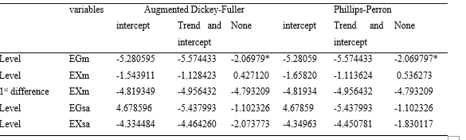Source: Eviews10; Authors calculation
*5% significance level, all other variables stability orders are significant less than 1%.

Table 1 reports the test results using both methods which are conducted with the trend, intercept and none. The unit root tests confirm that the dependent variable EG is stable at the level; for middle east-north Africa and SA cases. The same test results show that exports are stable at the level for the middle-east and at the first difference for the other country group case. However, all the results are significant at the 1 % level or lower.

Cointegration Tests:

The essential step to establish a meaningful long-run relationship, is the utilization of the appropriate cointegration tests among underlying variables, other than Engle and Granger (1987) procedure. Among them is; Autoregressive Distributed Lag cointegration technique or bound cointegration testing technique (ARDL).

The case of (MENA) countries:

The (ARDL) procedure can be applied because the underlying variables are stable at different orders. While (EGm) is stable at level I.e. I(0), the (EXm) is stable at the first difference i.e. I(1). The findings are as following:

Bound test:

Bound F-statistic is employed in order to find a long-term relationship among the variables. This bound F-statistic is run out on all the variables as they stand as an dependent variable while others are presumed as external variables (NKoro E. & kelvin A., 2001). ARDL bound test findings are showed in the table 2: below:

Table 2: bound test result
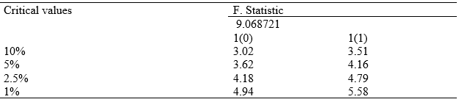Source: Eviews10; Authors calculation

In table 2 it is noticed that the statistical value (F) is (9.068721), which is greater than the maximum critical values at the level of (1%) which equals (5.58). So, the results suggest the existence of a level relationship (a long-run relationship) for the dependent variable and its repressor since the null hypotheses are rejected at 0.01, 0.05 or 0.10 levels.

Long-run coefficients:

In Table 3 a positive but none significant impact of Exports (EX_{m}) on economic growth rates (EG_{m}), i.e., the exports have no significant effects on economic growth in the long-term periods rather than the Bound test findings in table 2.

Table 3: Long-term estimates

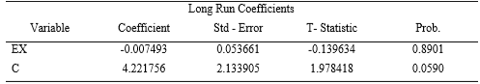
Source: Eviews10; Authors calculation

Short-run relationship:

Table 3 shows partially different results; it was also found a none significant short-run relationship between Exports (EX_{m}) and economic growth, when we consider for (EX_{m}) with one lag, whereas for D(EX_{m}) there exists a positive and significant short-run effect of exports on economic growth but, only at 10% level of significance.
The results of the error correction model showed that the error correction slowdown coefficient reveals the speed (or slow) of the variables returning to the equilibrium state. The negative signal shows the short-run dynamic model convergence and the negative and moral coefficient associated with slowing the error correction limit is a more effective way of demonstrating cointegration.

Table 4: short-term estimates

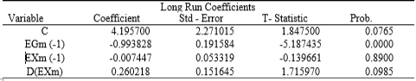
Source: Eviews10; Authors calculation

In this model, the value of the error correction coefficient - the error correction speed – is (-0.993828). We would like to note that this has a strong statistical significance at the level of 0.000%, which increases the accuracy and validity of the equilibrium relationship in the long run. It also indicates that the growth rate in one slow period reached (-0.993828), with a negative signal and a probability of 0.000, which means that the annual growth rate passes shocks in the short term by (-1.993828) years. That is, the growth rate is dependent on its long-term equilibrium over a period of (1.993828) years, and passes full shocks during mentioned period.

The case of (SA) countries:

While the unit root test indicates that both variables are stable at the level then, Engle-Granger test will be adopted which intern could be done within two steps:
1. Estimating the cointegration regression by OLS, obtaining the residuals (ût).
2. Applying unit root test for ût.
To test an equilibrium assertion, the null Hypotheses that ût has a unit root against the alternative that it has a root less than unity will be tested. The OLS regression estimators are in the table 5 below.
Since the coefficient of exports is non-significant then we accept the Null hypotheses i.e., there is no relationship between export growth and economic growth in South-Asian countries. Furthermore, there is a very low and negative value of Adjusted R-squared. To test whether there is a cointegration between the two variables, we follow the second step; i.e. the stationary test of the residuals via (ADF) tests.

Table 5: OLS regression estimators

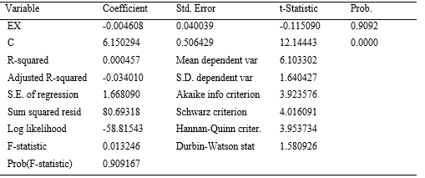
Source: Eviews10; Authors calculation

Following the results in table 6 we find that the residuals (Ut) are stable at level and significance at less than 1% level or. This indicates the presence of cointegration between export growth and economic growth in South-Asian countries.

Table 6: ADF stationary test

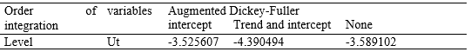
Source: Eviews10; Authors calculation

According to the MacKinnon (1991) critical values adjusted for the number of variables, the 5.0% critical τ value is −3.29. Since the computed τ (= t) value is more negative than this, our conclusion is that p- value estimated is significant. Accordingly the residuals from the regression of EXsa on EGsa are I(0) . This means the rejection of the null Hypothesis. Therefore, there is evidence of a cointegration relationship between EXsa and EGsa.

Structural stability tests of estimated Models:

The figures (1,2,3,4) below, shows structural stability of the time series for MENA and, SA countries. However , the total cumulative sum control chart CUSUM remaining for this pattern is an average line within the boundaries of the critical region, indicating the stability of the pattern at a large 5% boundary in figures(1,3,4), which indicates the structural stability of the parameters, because they are all within the limits of confidence during the study period, even the cumulative sum of the squares of the residuals (CUSUM of Squares) Figure (2), shows some breakpoints during the period (1997-1994).

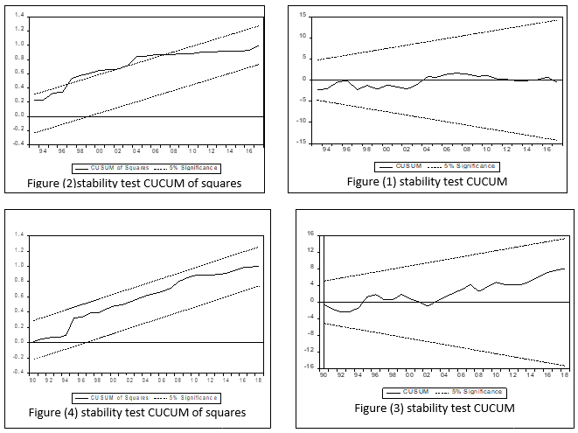
Source: Eviews10; Authors calculation

Diagnostics tests:

Here we will test for both serial correlation and Heteroscedasticity between the errors. For testing the hypothesis of non-correlation of errors, we use a serial-correlation test (Breusch-Godfrey Serial Correlation- BG) since it is valid in the presence of stochastic repressors such as lagged values of the dependent variable for higher-order autocorrelation. The BG test computes the Lagrange multiplier test for non-independence in the error distribution (Ljung &Rumana, 2012). Hence table 7 shows that Lagrange multiplier LM <𝜒2 and probability values are not significant at 5%, this indicates that there is no subjective correlation for the remainder of the estimated a model, and we then reject the Null Hypothesis of being there a serial correlation between the errors.

Table 7: Breusch-Godfrey Serial Correlation test outputs

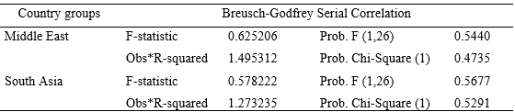
Source: Eviews10; Authors calculation

There are several tests to detect whether the residuals are homogeneous or not, among them the ARCH test. It was found that the model does not suffer from the Heteroscedasticity, while the value of LM <𝜒² and the probability values are not significant at 5%, and this indicates the Homoscedasticity of the residuals estimated, as shown in the table 8 below:

Table 8: Heteroscedasticity Test outputs: ARCH
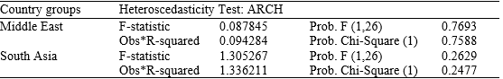
Source: Eviews10; Authors calculation

Granger causality test:

The regression analysis, however does not essentially imply causation or the direction of effect. Meanwhile, involving time series data, it may be to some extent different (Gujurati,2004). Since there is cointegration amongst the series, the vector error correction model will be used to test the direction of causality. The presence of a cointegrating vector allows for the use of a vector error correction model to test causality. According to a test developed by Granger (1969), a variable (X, for example) is said to Granger cause another variable (Y), if the values of X aid to predict the values of Y. To test if exports Granger causes growth, this paper applies the causality test developed by Granger (1969) (Gujarati, 2004).
The results of the Granger causality test are presented in Table 9. The results for the MENA countries show that there no Granger causality between economic growth and exports for the two directions. For the SA countries, we note a unidirectional causality from economic growth to exports. These results provide evidence that growth in both country groups was not propelled by an export-led growth strategy. Exports aren’t thus seen as the source of economic growth in mentioned countries.

Table 9: Granger causality test outputs

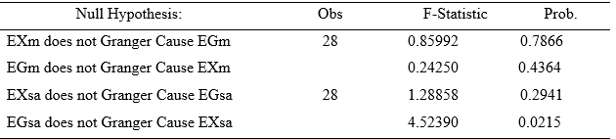
Source: Eviews10; Authors calculation

Conclusions:

The aim of this study is to carry out the relationship between exports and economic growth. For this purpose, the main questions are how the exports impact economic growth. Accordingly, the study re-examines the export-led growth hypothesis for the two developing country groups i.e. the MENA and, SA countries. The exports are measured as the annual growth rate of exports, and economic growth as the annual growth rate of real GDP. Using standard time series procedures of unit root testing via (ADF, PP) tests, cointegration, and error correction modeling and Granger causality tests.
Unit root tests, using both methods which are conducted with the trend, intercept and none confirm that the dependent variable EG is stable at the level; for (MENA) and SA cases, but the EX is stable at the level for the (MENA) countries, and EX is stable at the first difference SA country group case. However, all the results are significant at the 1 % level or lower. It was found the evidence for long-run cointegration relationships between the exports and economic growth in both cases. But there is no evidence for significant relations between them.
The findings of the causality test show that there no Granger causality amongst GDP growth and exports in the two directions for the MENA countries. But for the SA countries, we note a unidirectional causality from economic growth to exports.
The above findings indicate that growth in both country groups was not driven by an export-led growth strategy. Exports aren't thus seen as the cause of GDP growth in both cases.
The test of the effectiveness using Wald residuals statistics show that the model has no ARCH effect, the residual is normally distributed and the model does not have serial correlation and free from Heteroscedasticity. Given the results of the two cases and, because of trade agreements, exports are no longer the main determinant of economic growth because most countries, including developing countries, have the ability to export to most other countries. Thus, the factors of economic growth remain the subject of future research projects. Finally, the study suggests that output growth and export promotion strategies can be pursued with a focus on sustainable and inclusive growth.

List of references:
Abdulnasser H. and I. Manuchehr (2000), “Time-series Evidence for Balassa’s Export-led Growth Hypothesis”, Journal of International Trade and Economic Development, 9, 3, 355-365.
Abbas, S. (2012). Causality between Exports and Economic Growth : Investigating Suitable Trade Policy for Pakistan. Eurasian Journal of Business and Economics, 5(10), 91–98.
Baharumshah, A. Z., & Rashid, S. (1999). Exports, imports and economic growth in Malaysia: Empirical evidence based on multivariate time series. Asian Economic Journal, 13(4), 389–406.
Balassa, B. (1978). Export incentives and export performance in developing countries: A comparative analysis. Weltwirtschaftliches Archiv, 114(1), 24–61.
Balassa, B. (1985). Trade Between Developed and Developing Countries’: the Decade Ahead. Economic and Political Weekly, 7–25.
Bhagwati, J. N. (1988). Export-promoting trade strategy: Issues and evidence. World Bank Research Observer, 3(1), 27–57. https://doi.org/10.1093/wbro/3.1.27
Bilas, V. et el. (2015). Examining the Export-led Growth Hypothesis: The case of Croatia. Naše Gospodarstvo/Our Economy, 61(3), 22–31. https://doi.org/10.1515/ngoe-2015-0010
Busse, M., & Koeniger, J. (2012). Trade and Economic Growth: A Re-Examination of the Empirical Evidence. SSRN Electronic Journal. https://doi.org/10.2139/ssrn.2009939
Dutt, S. et el. (2015). Export Growth-economic Growth Nexus: An Empirical Re-examination. Journal of Business and Economics, 6(12), 1999–2007. https://doi.org/10.15341/jbe(2155-7950)/12.06.2015/001
Ekanayake, E. . (1999). Exports and Economic Growth in Developing Countries: Cointegration and Error-Correction Models. International Advances in Economic Research, 5(1), 147–148. https://doi.org/10.1007/BF02295041
Furuoka, F. (2007). Do exports act as “engine” of growth? Evidence from Malaysia. Economics Bulletin, 6(37), 1–14.
Ghatak, S., & Price, S. W. (1997). Export composition and economic growth: Cointegration and causality evidence for India. Review of World Economics, 133(3), 538–553. https://doi.org/10.1007/bf02707502
Gokmenoglu, K. K., Sehnaz, Z., & Taspinar, N. (2015). The Export-Led Growth: A Case Study of Costa Rica. Procedia Economics and Finance, 25(May), 471–477. https://doi.org/10.1016/s2212-5671(15)00759-5
Gujarati, D. N., & C.Porter, D. (2009). Essentials of Econometric. https://doi.org/10.1177/014662168400800314
Hallaert, J. J. (2006). A history of empirical literature on the relationship between trade and growth. Mondes En Developpement, 34(3). https://doi.org/10.3917/med.135.0063
Hamori, S. et. al. (2003). Trade and Growth Relationship: Some Evidence from Comoros, Madagascar, Mauritius and Seychelles. Asian and African Area Studies, 3, 174–185.
Huang, C. &. (2002). The Relationship Between Exports And Economic Growth In East Asian Countries: A Multivariate Threshold Autoregressive Approach. Journal of Economic Development, 27(2), 45–68.
Huang, J., & Ramirez, M. D. (2016). Do Exports lead Economic Output in Five Asian Countries? A Cointegration and Granger Causality Analysis. Business and Economic Research, 6(2), 30. https://doi.org/10.5296/ber.v6i2.9747
Ibrahim, M. H. (2002). An Empirical Note on the Export-Led Growth Hypothesis: The Case of Malaysia. Economic Analysis and Policy, 32(2), 221–232. https://doi.org/10.1016/S0313-5926(02)50030-8
Ikram, S. et al. (2018). Impact of Export, Import and Growth: Evidence Using Econometric Analysis in Malaysia. International Journal of Accounting, Finance and Business, 3(16), 12–19. Retrieved from www.ijafb.com
James Riedel. (2016). Trade as the Engine of Growth in Developing Countries , Revisited Author ( s ): James Riedel Published by : Wiley on behalf of the Royal Economic Society Stable URL : http://www.jstor.org/stable/2232215. 94(373), 56–73.
Kugler, P. (1991). Exports and Cointegration: An Empirical Investigation. 1(1991), 73–82.
Loewy, D. B.-D. and M. B. (2008). Trade openness and economic growth: Is growth export-led or import-led? Applied Economics, 40(2), 161–173.
Matsane S.H. (2010). Empirical Investigation on the Relationship between Trade Openness and Gross Domestic Product Growth Rate: The Case of South Africa (1980-2010).
Michaely, M. (1976). AND GRCWTH An empirical iavestiption Michael MICHAELY*. 4(I 977), 1975.
Narayan, et el. (2007). Export-led growth hypothesis: Evidence from Papua New Guinea and Fiji. Journal of Economic Studies, 34(4), 341–351.
Nath, H. K. (2005). Export-led growth in Bangladesh: A time series analysis. Applied Economics Letters, 12(6), 361–364.
Rizavi, S. e. el. (2010). Openness and Growth in South Asia. A Research Journal of South Asian Studies, 25(2), 419–428.
Ronit, M. (2014). The Relationship between the Growth of Exports and Growth of Gross Domestic Product of India. International Journal of Business and Economics Research, 3(3), 135. https://doi.org/10.11648/j.ijber.20140303.13
Saaed, A. A. J., & Hussain, M. A. (2015). Impact of Exports and Imports on Economic Growth : Evidence from Tunisia. Journal of Emerging Trends in Economics and Management Sciences (JETEMS), 6(1), 13–21.
Samad A.(2019).Does exports lead economic growth?or other way? VEC -Granger causality evidence from nine outh asian countries. Journal of Applied Business and Economics, 21(2). 117-128.
Sayef Bakari. (2017). The nexus between exports, imports, Domestic investment and Economic growth in Japan. Economic Policy, (2116), 0–33.
Sen, S. (2012). International Trade Theory and Policy: A Review of the Literature. SSRN Electronic Journal. https://doi.org/10.2139/ssrn.1713843

