Analysis of online trading transaction (peer to peer) on e-commerce based on Islamic law

Richardy Affan Sojuangon Siregar, Hersy Ayu Qadrya, Bella Marisela Caroline,
Atthiya Prima Sari, Tris Renanda, Luqman Isyraqi Lazuardi, Ramadana Arbi

Information System Study Program, Faculty of Science and Technology, State Islamic University of Syarif Hidayatullah
Jakarta; email: richardyaffan@gmail.com
DOI : 10.20885/jielariba.vol3.iss1.art4

Abstract: E-commerce lets buyers order things over the Internet via gadgets wherever they are and whenever they want to. The order will be delivered right to the buyer’s doorstep. There are several e-commerce models at the moment. One model is called peer-to-peer model which has been implemented on three largest e-commerce platforms in Indonesia. The validity of e-commerce from Islamic view is studied in order to clear the Muslims doubt regarding transactions made online. After scrutinizing the peer-to-peer model on e-commerce platforms through the lens of sharia, this article argues that there is an Islamic explanation regarding the validity of e-commerce by means of akad Wakalah bil Ujrah, akad Wakalah, and akad As-Salam. Primary data sources are data obtained from direct observation research in salam transactions, wakalah transactions, and wakalah bil Ujrah transactions. Primary data sources are also obtained from online articles written by scholars that can support the authors’ argument in this article. Secondary data sources used for the completion of this article are obtained from The Quran, Hadith, Council of Indonesian Ulama (MUI)’s fatwas, and related journals. After analyzing the process that took place in an e-commerce transaction using the peer-to-peer model, the authors conclude that there is an Islamic explanation regarding the validity of e-commerce based on peer-to-peer model in Indonesia and the validity of e-commerce is proved legal and acceptable in Islam.
Keywords: E-Commerce, Peer to Peer, Wakalah bil Ujrah, Wakalah, As-Salam

Introduction
The development of digital era, particularly internet, has been widely developed globally. As a result, traditional trade transaction has been shifted to the online system of trading. Although this trading system is essentially similar to the common trading system, the sellers and customers are not required to meet face-to-face in this online system. In response to the advancement of internet and the change of customers’ attitude, e-commerce has been growing recently. E-commerce is the utilization of computer and communication networks to conduct business matters. Further, e-commerce is commonly viewed as the use of internet and computer through web browsers as means to sell and purchase products (McLeod & Schell, 2008).
As a country with extensive amount of internet users, Indonesia becomes a strategic place for online business developers to cultivate the prospective opportunities in this country. According to the multiple-responses method survey released by CHIP conducted throughout February to April 2016 and involved 2.700 respondents, the most widely visited e-commerce sites by customers in Indonesia include Lazada, Tokopedia, dan Bukalapak (Tribun Jabar, 2016).
In the view of Islamic principles, the online trading system (e-commerce) as well as the trade in muamalah context can be considered legitimate if the transaction and covenant (akad) follow the principles stated in the Al-Qur’an as well as al-hadis. Moreover, the trading system should also consider public interest. Based on the above statement, therefore, there is a number of Islamic shari’a covenant (akad) incorporated in the online system of e-commerce in Indonesia. However, each e-commerce in Indonesia does not specifically classify what types of covenant (akad) that follow Islamic shari’a values incorporated within the purchasing system.
Based on the background above, it can be considered that this research will discuss the perspective of online transaction system (peer to peer) on e-commerce in Indonesia through the lens of Islamic shari’a principles. Furthermore, it is expected that this research will reassure the customers to select online transaction system (peer to peer) on e-commerce in Indonesia and to discover the types of the transaction system which follow Islamic shari’a principles.

Sale and Purchase
According to KUH (Indonesian Civil Code) Chapter 5 Sale and Purchase article 1457, sale and purchase is defined as the agreement of a party which obliges itself to deliver goods, whereas another party is required to compensate for the agreed price.

In terms of fiqh, the process of selling and purchasing is termed as al-bai’ which means to sell, compensate, or exchange one particular item with another. In Arabic, the term al-bai’ is sometimes used for the opposite meaning, which is asy-syira’ (purchase). Consequently, the word al-bai’ also means selling as well as purchasing (Haroen, 2007). Sale and purchase is the exchange of goods between two parties with voluntary principle based on the agreement between two parties, as well as justified and agreed by the two parties. Alternatively, it is also defined as the transfer of right and ownership from a party to another conducted through the exchange of goods (barter) as well as the transfer through the adjusted means (Kalbuadi, 2016).

The fundamental law of online business is considered similar to the sale and purchase transaction covenant (akad), which is allowed in Islam. Online business model is considered illicit if:
- The system is iniquitious, such as money gambling. This is because gambling is forbidden both in offline and online system
- The goods/service exchanged comes from forbidden sources
- The agreement is violated, or allegedly considered as a fraud
- The transaction will not result in expedience, instead it will result in harm
- The transaction contains values which make it illegitimate, such as usury, unjustness, fraud, deceit, and other things

Sale and purchase is a transaction covenant which can be considered legitimate when it follows all purchasing commandments and conditions. Covenant (akad) is a relationship tie between seller and customers. The transaction process cannot be considered legitimate if the solemn covenant (ijab qabul) has not been administered, since it represents compliance between both parties (Kalbuadi, 2016).

E-commerce
E-commerce is a the exchange process of goods and service, including customer service, in collaboration with business partners through a means of internet connections (Turban, 2005). The electronic transaction, e-commerce, is also defined as the utilization of communication device and computer to administer business processes. Moreover, it is commonly perceived that e-commerce is using internet and computer through web browser as means to sell and purchase products (McLeod & Schell, 2008).

There are 3 payment methods to be selected on e-commerce transaction process (Prihatna, 2005, p. 19):
- Online Processing Credit Card, this method is considered suitable for retail products with the marketplace is across the globe. The payment is done by real time process.
- Money Transfer, this method is more protected to receive payment from the overseas customers, though it will require additional cost for the customers in the form of fee for the money transfer service providers to send money to different countries.
- Cash on Delivery, the on-site payment can only be done if the customers are within the same city with the service providers.

Online Transaction Related Covenants (Akad)
The term akad is derived from Arabic al-aqad which etymologically means covenant, agreement, and consensus. Terminologically, akad has different meanings, including ‘contract’ as stated in Q.S. Al-Maidah:1 which means: “O you who have believed, fulfil [all] contracts …” In the agreement of ijarah (the exchange of goods/services), covenant is considered as a bond which binds the parties. As a result, the parties who wish to express their desire are required to make a statement which is called as ijab and qabul. Ijab is the initial statement from a party who has a desire, while qabul is the response from the other side. It is conducted after ijab is expressed to show the agreement to exchange when ijab qabul has already fulfilled the agreed conditions.

As-Salam Covenant
Terminologically, As-Salam is defined as selling goods with postponed handover, or selling goods with describing the characteristics and capital payments beforehand, while the handover is conducted afterwards (Hasan, 2003).

Agreement Right (Haq Khiyar)
Haq Khiyar occurs when the two parties who are transacting decide to form conditions, or when one party uses their right to form conditions until the agreed limit of time. This circumstance is considered allowed even when the time validity is long enough. “Indeed, two persons who conduct transaction have the right to form conditions (haq khiyar) during their transaction before they part, or the transaction implements khiyar covenant.” (Muttafaqun ‘alaih: Fathul Bari IV: 326 no: 2107, Muslim III: 1163 no: 1531 and Nasa’i VII: 248).

Wakalah Covenant
Wakalah or wikalah can be defined as the process of handover, delegation, or submission of the mandate.
Wakalah is the devolution of authority from a person as the first party toward other person as the second party in the delegation process of authority (in this case, the second party) mandated by the first party. However, if the 35 responsibilities have been fulfilled as agreed, the first party (or the authorizer) solely bears the risk as well as the responsibilities (Faza, 2009).

Wakalah bil Ujrah Covenant
Wakalah bil Ujrah is considered similar to Wakalah. However, in Wakalah bil Ujrah, there is an agreement between the seller and e-commerce developer to share the benefits based on the agreed terms (fee sharing). Wakalah covenant deals with mandate (yad amanah) not amenability (yad dhaman). Wage (ujrah) deals with every asset, in the form of money or goods, provided as the compensation for every project administered which has the value of property (maal), including every asset that can be utilized. In the decree of National Sharia Council (DSN), the amount of wage (ujrah) should be agreed upon the initial project and declared in the form of nominal instead of percentage.

Research Method
As the research employs qualitative method, the types of data gathered in this research are closely related to qualitative data with the emphasis on deepening of issues, including:
  - Data on online trading transaction at the three biggest e-commerce in Indonesia
  - Islamic law dealing with online trading transaction
In order to strive to achieve scientific truth, the source of data needed during this research is classified into two parts:
  - Primary research sources, which deal with data obtained directly from observation throughout the process of salam, wakalah, wakalah bil ujrah online transaction as well as related documents from the internet.
  - Secondary research sources, which deal with document and literature review relating to the current research, which include:
- Al-Quran
- Hadith
- Indonesian Council of Ulama (MUI) Decree
- Related journals
The data was collected through the literature and document reviews from books on selling transaction in Islamic principles as well as the documents related to e-commerce in Indonesia.
To answer the research questions, the data was analysed through the following methods:
a) Descriptive Method
This method is employed to discover and describe the implementation of online trading transaction on e-commerce in the lens of Islamic sharia law.
b) Inductive Thinking Model
It is an approach started from specific statements derived from particular facts on online trading transaction at the three biggest e-commerce in Indonesia. This data is then elaborated comprehensively as means to uncover general argumentation.

Result and Discussion

E-Commerce Transaction Model with Profit Sharing
In this transaction model, there is a profit sharing method between the seller and e-commerce site. The sharing is calculated for each item and in the form of Rupiah.
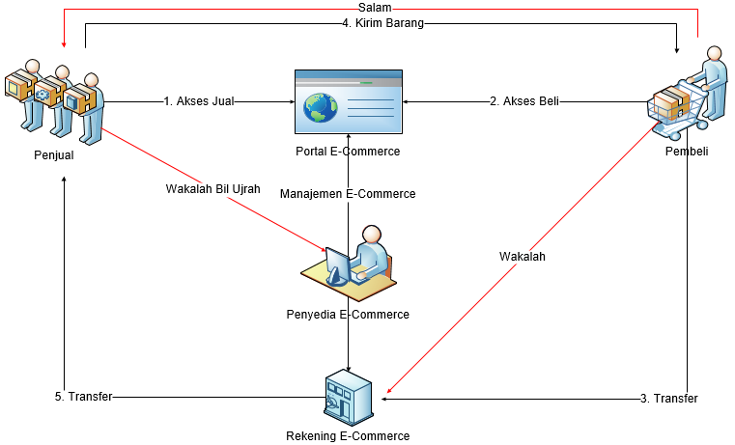
Picture. 4.1 E-Commerce Transaction Model with Profit Sharing
There are several phases in Picture 4.1, including:
- The sellers access e-commerce sites to market their products. During this process, wakalah bil ujrah covenant is also conducted, in which there is a profit sharing agreement from the seller to the e-commerce providers.
- The customers access e-commerce sites to purchase products, in which the sellers and customers agree to conduct selling process afterwards.
- The payment method is administered through transfer process, in which the customers send certain amount of money to e-commerce (e-commerce bank account) where wakalah covenant is also being involved within the process.
- After the payment is transferred, the seller will then deliver the goods to the customer where As-Salam covenant is being involved from the customer to the seller.
As depicted in the transaction model in Picture 4.1, wakalah, wakalah bil ujrah and salam covenants are directly being involved within the transaction process, in which those can be referred to the Islamic sharia law:
- Wakalah Covenant
Etymologically, wakalah means al-Tafwidh (the process of handover, delegation, or submission of the mandate). Wakalah deals with certain transaction, in which a person entrusts another person to substitute their duty to conduct particular matters when they are still alive (Ghazaly, Ihsan, & Shidiq, 2015).
- Al-Quran Surat al-Baqarah verse 283:
Translation: “..And if one of you entrusts another, then let him who is entrusted discharge his trust [faithfully] and let him fear Allah, his Lord. …”.
- Al-Hadist:
“Rasullulah SAW delegates Abu Rafi’ and an Anshar to marry (the Prophet’s response [qabul] for) Maimunah r.a”
- National Sharia Council Decree: 10/DSN-MUI/IV/2000 regarding Wakalah.

- As-Salam Covenant
Terminologically, As-Salam deals with selling goods with postponed handover, or selling goods with describing the characteristics and capital payments beforehand, while the handover is conducted afterwards i (Hasan, 2003).
- Allah’s Commandment in QS. al-Baqarah [2]: 282:
Translation: " O you who have believed, when you contract a debt for a specified term, write it down....".
- Prophet’s saw Hadith.
Translation: “From Abu Sa’id Al-Khudri, Rasulullah SAW stated that, ‘Indeed, the selling process should be conducted based on consensual agreement.” (Hadith Narrated by. al-Baihaqi dan Ibnu Majah, and is considered valid by Ibnu Hibban).
- Hadith narrated by Bukhari and Ibn ‘Abbas, Prophet saw stated that
Translation: "Whosoever commits salaf (salam), they should conduct it with clear measurement and balance for the known time span " (Hadith Narrated by Bukhari, Sahih al-Bukhari [Beirut: Dar al-Fikr, 1955], volume 2, page. 36).

- Wakalah bil Ujrah Covenant
Wakalah bil Ujrah is considered similar to Wakalah. However, in Wakalah bil Ujrah, there is an agreement between the seller and e-commerce developer to share the benefits based on the agreed terms (fee sharing).
- Al-Quran surah An-Nisa ayat 58
Translation: “Indeed, Allah commands you to render trusts to whom they are due and when you judge between people to judge with justice. Excellent is that which Allah instructs you. Indeed, Allah is ever Hearing and Seeing.”
- Al-Quran surah An-Nisa ayat 29:
Translation: “O you who have believed, do not consume one another's wealth unjustly but only [in lawful] business by mutual consent. And do not kill yourselves [or one another]. Indeed, Allah is to you ever Merciful.”
- Hadith
“Narrated from Busr bin Sa’id that Ibn Sa’diy al-Maliki stated: Umar employed me to gather alms (Zakat). After I gathered and delivered the alms to him, Umar ordered that I shall be given fee. Thence, I said: I only submitted to Allah. Umar responded: Take what you have given; I used to work like you during the times of Rasulullah, he then gave me fee; I also said what you have said. Thence, Rasulullah commanded to me: If you are given something without asking, consume (accept) it and give alms.” (Muttafaq ‘alaih. Al-Syaukani, Nail al-authar” (Al-Syaukani, 2000, p. 527).

E-commerce Transaction Model without Profit Sharing
This transaction model is settled without involving profit sharing between the sellers and e-commerce.
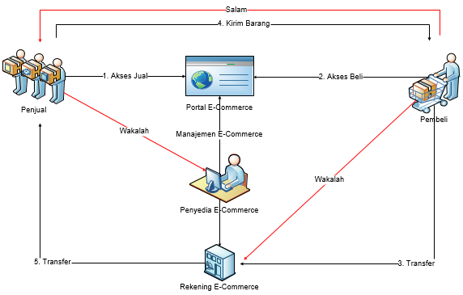
Picture. 4.2 Transaction Model without Profit Sharing

In Picture. 4.2, there are several phases, which include:
- Sellers access e-commerce portal to market their products. Throughout the transaction process, wakalah covenant is directly being involved between the seller and the provider of e-commerce.
- Customers access e-commerce portal to initiate purchasing, the customers and sellers will then agree to conduct purchasing process.
- The payment method is administered through transfer, in which the sellers transfer certain amount of money to e-commerce provider implementing wakalah covenant during this process.
- Once the money has been transferred, the seller will then deliver the items to the customers through the implementation of Salam covenant from the customer to the seller.

By analysing the transaction model in picture 4.2, it can be identified that wakalah and salam covenants can be referred into sharia law:
- Wakalah covenant
Etymologically, wakalah refers to al-wakalah, which means al-Tafwidh (handover, delegation, or submission of the mandate). Wakalah deals with certain transaction, in which a person entrusts another person to substitute their duty to conduct particular matters when they are still alive (Ghazaly et al., 2015).
- Al-Quran Surah al-Baqarah verse 283:
Translation: “..And if one of you entrusts another, then let him who is entrusted discharge his trust [faithfully] and let him fear Allah, his Lord. …”.
- Al-Hadist:
“Rasullulah SAW delegates Abu Rafi’ and an Anshar to marry (the Prophet’s response [qabul] for) Maimunah r.a”
- National Sharia Council Decree: 10/DSN-MUI/IV/2000 Regarding Wakalah.

- As-Salam Covenant
Terminologically, As-Salam deals with selling goods with postponed handover, or selling goods with describing the characteristics and capital payments beforehand, while the handover is conducted afterwards (Hasan, 2003).
- Allah’s Commandment in QS. al-Baqarah [2]: 282:
Translation: " O you who have believed, when you contract a debt for a specified term, write it down....".
- Prophet’s saw Hadith.
Translation: “From Abu Sa’id Al-Khudri, Rasulullah SAW stated that, ‘Indeed, the selling process should be conducted on the basis of consensual agreement.” (HR. al-Baihaqi dan Ibnu Majah, serta dinilai shahih oleh Ibnu Hibban).
- Hadith narrated by Bukhari and Ibn ‘Abbas, Prophet saw stated that
Translation: "Whosoever commits salaf (salam), they should conduct it with clear measurement and balance for the known time span " (HR. Bukhari, Sahih al-Bukhari [Beirut: Dar al-Fikr, 1955], volume 2, page. 36).

COD (Cash On Delivey) Transaction Model
Haq Khiyar is directly involved throughout the process of transaction between the sellers and customers.
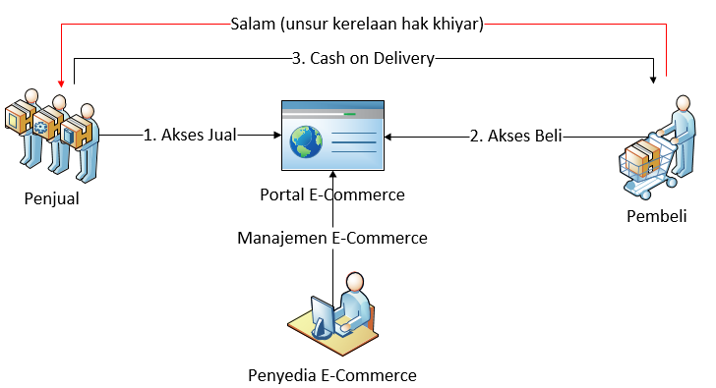
Picture. 4.3 COD Transaction Model

In Picture 4.3, there are several phases undertaken during the transaction process, including:
- Sellers access e-commerce portal to market their products.
- Customers access e-commerce portal to initiate purchasing process, thence sellers and customers make an agreement upon the purchasing transaction.
- The payment and delivery process of the item is conducted through Cash on Delivery process between the seller and customer, in which it also involves Salam covenant with voluntary haq khiyar between the seller and the customer.

- As-Salam covenant
Terminologically, As-Salam deals with selling goods with postponed handover, or selling goods with describing the characteristics and capital payments beforehand, while the handover is conducted afterwards (Hasan, 2003).
- Allah’s Commandment in QS. al-Baqarah [2]: 282:
Translation: "O you who have believed, when you contract a debt for a specified term, write it down....".
- Prophet’s saw Hadith.
Translation: “From Abu Sa’id Al-Khudri, Rasulullah SAW stated that, ‘Indeed, the selling process should be conducted based on consensual agreement.” (HR. al-Baihaqi dan Ibnu Majah, serta dinilai shahih oleh Ibnu Hibban).
- Hadith narrated by Bukhari and Ibn ‘Abbas, Prophet saw stated that
Translation: "Whosoever commits salaf (salam), they should conduct it with clear measurement and balance for the known time span " (HR. Bukhari, Sahih al-Bukhari [Beirut: Dar al-Fikr, 1955], volume 2, page. 36).

- Haq Khiyar (The right to select)
Haq Khiyar occurs when the two parties who are transacting decide to form conditions, or when one party uses their right to form conditions until the agreed limit of time. This circumstance is considered allowed even when the time validity is long enough.
The principle is justified by the hadith narrated by Ibnu Umar radhiyallahu ‘anhu, in which Prophet shallallahu ‘alaihi wasallam commanded: Indeed, two persons who conduct transaction have the right to form conditions (haq khiyar) during their transaction before they part, or the transaction implements khiyar covenant.” (Muttafaqun ‘alaih: Fathul Bari IV: 326 no: 2107, Muslim III: 1163 no: 1531 dan Nasa’i VII: 248).
Furthermore, it is also based on the hadith narrated by Habban bin Munqidz radhiyallahu ‘anhu. He was often cheated due to the obscurity of the item being sold, thence Prophet Nabi shallallahu ‘alaihi wasallam granted the right to select to him. He stated that:
“Tell them, if you want to purchase something, ‘There is no fraud’.” (Hadith Narrated by. Bukhari in al-buyu’, chapter ma yukrahu min al-khida’ fi al-bai’, no.2117, and in al-hiyal, no.4964; and Muslim in al-buyu’, chapter man yukhda’u fil bai’, no.1533).

Conclusion
After analysing several phases of e-commerce transaction (peer to peer), it can be concluded that there is an extensive explanation for the online trading transaction process (peer to peer) on e-commerce in Indonesia. Moreover, the transaction process has followed sharia law with the explanation as follows. The e-commerce transaction process with profit sharing involves wakalah bil ujrah, wakalah, and as-salam covenants, in which wakalah bil ujrah deals with profit sharing agreement between sellers and e-commerce that fulfills sharia principles as explained in the discussion part. Meanwhile, the e-commerce transaction model without profit sharing does not have profit sharing phase. Thus, e-commerce merely becomes a marketplace for the products which also follows sharia law elaborated in the discussion part. Further, COD (cash on delivery) transaction model involves salam covenant, in which this covenant is also followed by khiyar. In this case, khiyar means selecting the best of two options, including proceeding or cancelling the transaction process with the acceptable conditions based on sharia law discussed in the previous sections.
Therefore, it can be concluded that the transaction process of e-commerce elaborated above, which include Lazada as the e-commerce transaction model with profit sharing, the e-commerce transaction model with profit sharing, as well as COD (Cash On Delivery) transaction model have already fulfilled sharia principles. Moreover, the transaction process of Tokopedia in the category of e-commerce transaction model with profit sharing has also fulfilled sharia principles of transaction. Further, the transaction process of Bukalapak in the category of profit sharing has also followed sharia principles of transaction.

References
Al-Syaukani. (2000). Nail al-authar (Jilid 4). Cairo, Egypt: Daral-Hadits.
Faza, E. F. (2009). Tinjauan hukum Islam terhadap klaim asuransi dalam akad wakalah bil ujrah pada PT Asuransi Takaful Umum Surabaya. UIN Sunan Ampel. Retrieved from http://digilib.uinsby.ac.id/7924/
Ghazaly, A. R., Ihsan, G., & Shidiq, S. (2015). Fiqh muamalat. Jakarta, Indonesia: Kencana Prenada Media Group.
Haroen, N. (2007). Fiqh muamalah. Jakarta, Indonesia: Gaya Media Pratama.
Hasan, M. A. (2003). Berbagai macam transaksi dalam Islam. Jakarta, Indonesia: Raja Grafindo Persada.
Kalbuadi, P. (2016). Jual beli online dengan menggunakan sistem dropshipping menurut sudut pandang akad jual beli Islam (studi kasus pada Forum Kaskus). UIN Syarif Hidayatullah. Retrieved from http://repository.uinjkt.ac.id/dspace/handle/123456789/30460
McLeod, R., & Schell, G. P. (2008). Management information system (Edisi 10). Jakarta, Indonesia: Salemba Empat.
Prihatna, H. (2005). Kiat praktis menjadi web master professional. Jakarta, Indonesia: Elexmedia Computer.
Tribun Jabar. (2016). Survei membuktikan, 10 toko online Indonesia ini top dan banyak dikunjungi. Retrieved from http://jabar.tribunnews.com/2016/05/11/survei-membuktikan-10-toko-online-indonesia-ini-top-dan-banyak-dikunjungi
Turban, E. (2005). Introduction to information technology. New Jersey, US: John Wiley & Sons Ltd.

