STATEMENT LETTER
ABILITY OF ATTEND APPLICABLE RULES

(FORM 2)

I who is undersigned bellow:
No | Name | Address / email / phone number
1 | Handy Darmawan, M.D. | Jayeng Kusuma Street, No. 320, Ketanon, Kedungwaru, Tulungagung Regency, Indonesia (66229) / handy.darmawan92@gmail.com / +62895876825787
2
3
4
5

Hereby declare my ability to follow all applicable provisions in case writing and original article competition at FK UII. This declaration has been made without coercion from other parties. If there are any deception, omission or misconduct in this statement, I am willing to accept any consequences according to UII regulation.
.

1st Author  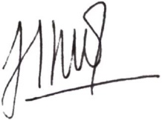  (Handy Darmawan, M.D.) | 2nd Author  (………………………….) | 3rd Author  (……………………………..)

