Formulir Copyright Transfer

JKKI
Jl. Kaliurang Km 14,5

ASSIGNMENT OF COPYRIGHT

Dear Contributor,

Please complete the details below (title and authors of paper), read the agreement, sign it and return it with your corrected proof.

Full Title of Paper: DERMATITIS KONTAK IRITAN AKIBAT GETAH POHON RENGAS (IRRITANT CONTACT DERMATITIS CAUSED BY RENGAS)

Authors (Full Names): Betty Ekawati Suryaningsih

With the submission of the paper entitled above and the acceptance for publication, I hereby assign all rights including the copyright in the said paper to the JKKI.

Please acknowledge receipt of this letter and your agreement with its terms by signing and returning it as quickly as possible.

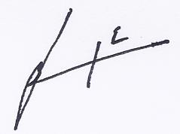
Dr. dr. Betty Ekawati Suryaningsih, SpKK., FINSDV 29 November 2019
Author’s Signature Date

