AUTHOR PUBLISHING AGREEMENT
JURNAL KEDOKTERAN DAN KESEHATAN INDONESIA
(FORM 3)

I who is undersigned bellow:
No | Name | Address / email / phone number
1 | Handy Darmawan, M.D. | Jayeng Kusuma Street, No. 320, Ketanon, Kedungwaru, Tulungagung Regency, Indonesia (66229) / handy.darmawan92@gmail.com / +62895876825787
2
3
4
5

By expressing consciously and without coercion from any parties in case report and original article competition conducted by JKKI. If I am designated as the winner, I hereby grant to JKKI to publish my manuscript based on the time specified by journal. I as the authors will also carry out my obligations for the smoothness of the process.

1st Author  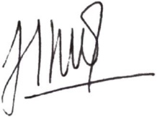  (Handy Darmawan, M.D.) | 2nd Author  (………………………….) | 3rd Author  (……………………………..)

