Therapeutic Plasma Exchange (TPE) as An Effective Supportive Therapy for Covid-19 case with Acute Respiratory Distress Syndrome (ARDS) and Hypercoagulopathy: Case Report
Reviono^{1,3,4}
Arifin^{2,4}

¹Department of Pulmonology and Respiratory Medicine Faculty of Medicine Universitas Sebelas Maret
²Department of Internal Medicine Faculty of Medicine Universitas Sebelas Maret
³Universitas Sebelas Maret Hospital, Surakarta
⁴Moewardi Hospital, Surakarta

ABSTRACT
Coronavirus Disease (Covid-19) has rapidly spread and caused a high number of mortalities. To this day, effective therapy to cure this virus is yet to be found. A number of treatments were tested; however, the result is not satisfactory. Therapeutic plasma exchange (TPE) is one of the supportive therapies applied to treat Covid-19 patients with moderate to severe symptoms. We reported 41 years old male patient diagnosed with severe Covid-19 infection, acute respiratory distress syndrome (ARDS), and hypercoagulopathy. The patient received a therapy following the Ministry of Health’s guideline for Covid-19 handling: hydroxychloroquine 2 x 200 mg, azithromycin 1 x 500 mg, vitamin C 1000 mg/12 hours, dexamethasone 2.5 mg, and heparin 18 iu/kg body weight/hour. On the third day, respiratory failure occurred with a P/F ratio of 255 and the chest x-ray result showed vascular streak and ground-glass opacity; thus, the hospital decided to perform TPE. The TPE was performed twice in 5 days interval. After TPE was administered, clinical development is observed both subjectively in the form of reduced symptoms, normal respiration rate, and objectively, the improvement in blood gas analysis, increased O₂ saturation, and a decrease in interleukin (IL) 6 and TNF α level Significant clinical laboratory and radiological improvement possibly due to cytokine storm which is remedied by TPE action.
Key Word: Therapeutic Plasma Exchange, Covid 19, ARDS
INTRODUCTION
Coronavirus disease 2019 (COVID-2019), which is caused by severe acute respiratory syndrome coronavirus 2 (SARS-CoV-2) has spread rapidly across the world due to its high transmissibility and pathogenicity.¹ An illness caused by the SARS cov2 virus, referred to as Covid-19, is determined as a pandemic on 11 March 2020. To this day, no therapy has been deemed effective, all of which are still under research. The virus infected the respiratory epithelium of the lower airways.² Covid-19 has diverse spectrums from asymptomatic infection to respiratory failure and patient death (Morath, 2020). Severe cases are related to cytokine storms that occurred as a result of excessive immune dysregulation, followed by hypercoagulable and endothelial dysfunction.^{3,4}
Cytokine storm is an unchecked feed ward activation and amplification of host range, which will trigger a massive release of a cytokine such as interferon (IFN)γ, tumor necrosis factor (TNF) interleukin (IL) 1, IL 6.⁴ To date, no therapy has been deemed effective, and extensive research is conducted, including in Indonesia. Therapeutic Plasma Exchange (TPE) is among the developed treatments included in supportive therapy,² and administered to severe and critical patients. This therapy has been known for more than a century and was developed for immune disorders, and is relatively safe and effective.⁵
CASE DESCRIPTION
A forty-one years old man visited UNS Hospital reporting fever and shortness of breath on October first. He received treatment from a different hospital for nausea, high fever, and chest x-ray showing normal. Therefore, treatment for typhoid fever was administered for him. The patient was referred to UNS Hospital after having no improvement and started to experience shortness of breath. At the initial examination, the routine blood check result showed a relatively normal condition with only a slight increase in neutrophil lymphocyte ratio (NLR): 3.9. However, the number is still below the average Covid-19 result of 5.⁶ The blood gas analysis showed an oxygen tension (PaO₂) of 95 mmHg and O₂ saturation (SaO₂) of 98% in the room air (FiO₂: 21%) or FiO₂/PaO₂ ratio: 457, however the nasopharynx real-time polymerase chain reaction (RT PCR) for SARS CoV2 showed a positive result. After the patient received a receiving standard therapy for Covid-19 following the Ministry of Health and Perhimpunan Dokter Paru Indonesia (PDPI)⁷ guideline with hydroxychloquine 1 x 400 mg azithromycin 1 x 500 mg, oseltamivir 2 x 75 mg, and vitamin C 1000 mg/8 hours, he experienced worse shortness of breath. Thus, another blood gas analysis and chest x-ray were conducted for clinical evaluation. This new blood gas test showed the decrease in PaO₂ from 95 mmHg to 84 mmHg on the administration of O₂ 3 litre/minute (FiO₂: 33%) resulted in a PaO₂/FiO₂ ratio of 254.5; therefore, it falls under the ARDS category.
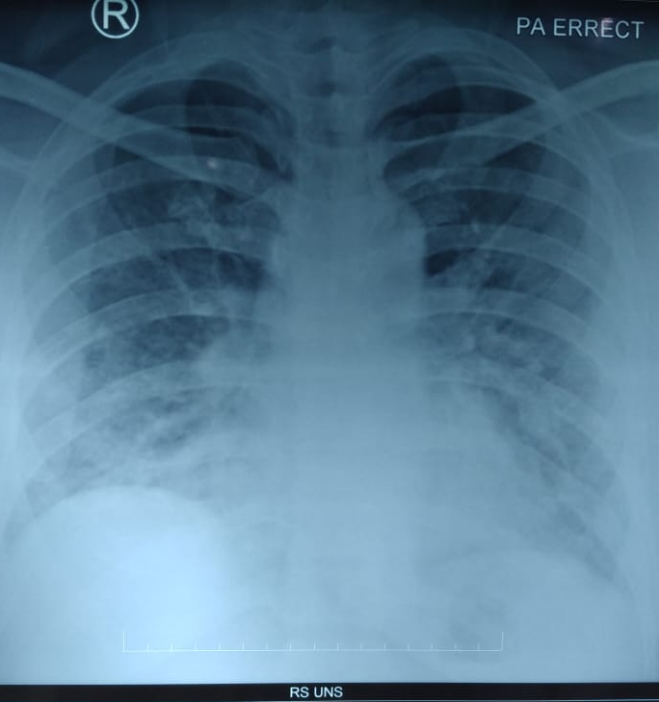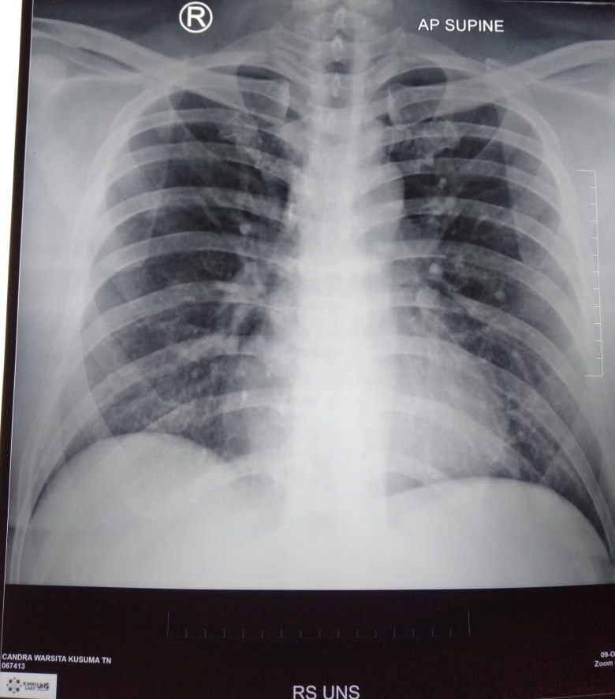
A B C
Figure 1. Radiological data of the stages of the illness
Notes: In figure A, the patient experienced fever and nausea and diagnosed with typhoid fever; in figure B, the patient reported shortness of breath, and the blood gas analysis showed respiratory failure, a visible increase in bronco vascular streak and infiltrates, TPE was then administered to the patient; in x-ray resu00lt C, the patient received TPE twice, the chest x-ray result went back to normal.
The result of the second chest x-ray showed an increase in infiltrates and clear vascular marking (figure 1). Another examination performed was D-Dimer = 629.29 ng/mL which means that there was hypercoagulopathy (normal level < 500 ng/mL) and the result of hs-CRP = 18.51 mg/L (normal level < 0.3 mg/L) which indicated the presence of viral infection. In Covid-19 infection with ARDS, respiratory failure, and hypercoagulopathy additional anti-inflammatory therapy was administered using dexamethasone 2.5 mg/ 8 hours, heparin 18 iu/kg bodyweights/hour, and TPE was performed. TPE was performed in the Covid-19 isolation room of UNS Hospital using the haemonetics machine MTS Plus and kit 980 E. According to the patient’s weight (70 kg) and hematocrit of 34.8, a total of 3204 cc plasma fluid will be extracted. In stage I, 2000 cc of plasma fluid was extracted, and another plasma fluid will be extracted in stage II after considering the patient’s clinical condition. In stage II, 1200 cc of fluid was extracted and was replaced with 4 flashes @ 250cc of albumin 5%, and thus, the replacement fluid consists of 1000 cc albumin 5% and 1000 cc crystalloid liquid. Before TPE was administered, an examination was conducted, and similar IL 6 levels: 391.220 pg/ml, and P/F ratio: 250 were obtained, which means there was no improvement compared to the previous examination. After the second TPE was administered in the interval of 5 days, significant clinical improvement was observed. The IL 6 measure decreased to 25.512 pg/ml and TNF α: 6.852 pg/ml, SaO2: 99 percent at the room air (21%). P/F ratio: 428.5 or normal (table 1). The patient experienced clinical improvement supported by the chest x-ray results, which showed a decrease in ground glass opacity to normal condition.
Table 1. Comparison of laboratory parameter and cytokine
 | D -1 | Before TPE | After TPE
pH | 7.55 | 7.46
BE | 5 | 0.7
pCO2 | 31 | 34
pO2 | 95 | 84 | 90
Hematocrit | 34.6 | 34.8
HCO3 | 27.4 | 24.2
Total CO2 | 28.4 | 25.2
O2 saturation | 98% | 97% | 99%
FiO2 | 21 | 33% | 21%
IL 6 |  | 391.22 | 25.51
TNFα |  | 22.85 | 6.85
P/F ratio | 457 | 254.5 | 471

DISCUSSION
The patient diagnosed with Covid-19, ARDS, respiratory failure, and hypercogulopathy experienced clinical improvement after TPE was administered. The therapy, also known as plasmapheresis, has been implemented for more than one century.⁸ In the guideline issued by the American Society of Apheresis for ARDS case, the administration of TPE is included in category III, or the optimum role of apheresis therapy is not established. Decision-making should be individualized.⁹ Covid-19 rarely caused severe respiratory failure, especially at the beginning of the infection.¹⁰ Usually, severe respiratory failure is caused by a highly pathogenic strain. Several studies in Wuhan showed that the increase of inflammation caused by cytokine storm is connected to mortality,¹¹ with low SaO₂ that will increase IL-6, IL-10, C-reactive protein (CRP), and TNFα, which in turn will cause cytokine storm. Interleukin 6 is the key cytokine that induces cytokine storm .^{5,12} Similarly, Covid-19 has a high risk of causing thrombosis, which will worsen the patient’s clinical condition.¹³ In general, TPE will be beneficial in cytokine storm case and provide hematologic support in the hemophagocytic related case. TPE with continuous hemofiltration (CHF) was proven to reduce the concentration of IL-6 and other cytokines in critical pathologies cases such as fulminant liver damage, autoimmune inflammation, neurological and infectious disease.¹⁴ TPE improves microcirculatory inflammation, clot formation, and hypotension; thus, improving clinical condition comprehensively.¹¹ The decrease of pro-inflammation cytokines is followed by clinical improvement marked by the increase in SaO2 after administering TPE twice compared to pre-TPE condition. Clinical improvement is also followed by the radiological improvement observed in the decreasing ground glass opacity in chest x-ray results after the second TPE administration. This TPE was successful because the patient did not experience severe respiratory failure (PF ratio is > 200); thus, the initial case handling is also a factor in the successful TPE administration.² When TPE was administered, the government or organization’s standard therapy was also provided concomitantly.¹⁴ The result of this case report showed that TPE could be administered for Covid-19 case with ARDS and respiratory failure, as reported by other researchers.¹¹ Thus, it provides an option in managing severe Covid-19 case.
CONCLUSION
Therapeutic Plasma Exchange can extract dangerous cytokines, such as IL-6, TNFα so that the infected body can reach clinical and radiological improvement. Research with a clinical trial is needed to provide further evidence for TPE selection as an option for Covid-19 supportive therapy.
REFFERENCE
- Zhang J, Xie B, Hashimoto K. Current status of potential therapeutic candidates for the COVID-19 crisis. Brain, Behavior, and Immunity Volume 87, July 2020, Pages 59-73

- Khamis F, Al-Zakwanib I, Al Hashmic S, et al. Therapeutic plasma exchange in adults with severe COVID-19 infection. International Journal of Infectious Diseases 99 (2020) 214–218. https://doi.org/10.1016/j.ijid.2020.06.064

- Keith P, Day M, Perkins L, et al. A novel treatment approach to the novel coronavirus: an argument for the use of therapeutic plasma exchange for fulminant COVID-19. Critical Care (2020) 24:128 https://doi.org/10.1186/s13054-020-2836-4

- Gao YM, Wang B, Liu BC. Cytokine storm syndrome in coronavirus disease 2019: A narrative review. The Association for the Publication of the Journal of Internal Medicine 1-11. doi: 10.1111/joim.13144

- Tabibi S, Tabibi T, Conic R, et al. Therapeutic Plasma Exchange: A potential Management Strategy for Critically Ill COVID-19 Patients. Journal of Intensive Care Medicine 2020, Vol. 35(9) 827-835. DOI: 10.1177/0885066620940259

- Song CY, Xu J, He JQ , Lu YQ. COVID-19 early warning score: a multi-parameter screening tool to identify highly suspected patients. MedRxiv preprin doi: https://doi.org/10.1101/2020.03.05.20031906

- Perhimpunan Dokter Paru Indonesia (PDPI) Perhimpunan Dokter Spesialis Kardiovaskular Indonesia (PERKI) Perhimpunan Dokter Spesialis Penyakit Dalam Indonesia (PAPDI) Perhimpunan Dokter Anestesiologi dan Terapi Intensif Indonesia (PERDATIN) Ikatan Dokter Anak Indonesia (IDAI). 2020. Pedoman Tatalaksana Covid-19. Edisi 2, Jakarta. pp.47-68

- Sokolov AA, Solovyev AG. Russian Pioneers of Therapeutic Hemapheresis and Extracorporeal Hemocorrection: 100-Year Anniversary of the World’s First Successful Plasmapheresis. Therapeutic Apheresis and Dialysis 2014; 18(2):117–121 doi: 10.1111/1744-9987.12067

- Schwartz Joseph, Padmanabhan A, Aqui N. Balogun RA, et al, 2016. Guidelines on the Use of Therapeutic Apheresis in Clinical Practice – Evidence-Based Approach from Writing Committee of the American Society for Apheresis : The Seventh Special Issue. Journal of Clinical Apheresis 31: 149 – 338. DOI: 10.1002/jca.21470

- Keith P, Day M, Choe C, et al. The successful use of therapeutic plasma exchange for severe COVID-19 acute respiratory distress syndrome with multiple organ failure. SAGE Open Medical Case Reports Volume 8: 1–4. DOI: 10.1177/2050313X20933473

- Morath C, Weigand MA, Zeier M, et al. Plasma exchange in critically ill COVID-19 patients. Critical Care (2020) 24:481 https://doi.org/10.1186/s13054-020-03171-3

- Wang J, Jiang M, Chen X, et al. Cytokine storm and leukocyte changes in mild versus severe SARS-CoV-2 infection: Review of 3939 COVID-19 patients in China and emerging pathogenesis and therapy concepts. J Leukoc Biol. 2020;1–25. DOI: 10.1002/JLB.3COVR0520-272R.

- Gucyetmez B, Atalan HK, Sertdemir I, et al. Therapeutic plasma exchange in patients with COVID-19 pneumonia in intensive care unit: a retrospective study. Critical Care (2020) 24:492 https://doi.org/10.1186/s13054-020-03215-8

- Zhuplatov S, Zhuplatov I. Removal of Endotoxins and Cytokines by Plasmapheresis Filtration with Plasma Exchange Therapy (TPE) Could Benefit Patients with Covid-19 in Critical Condition. J Anest & Inten Care Med 10(5): JAICM.MS.ID.555798 (2020). DOI:10.19080/JAICM.2020.10.555798.

