LAMPIRAN
- Iji Normalitas
One-Sample Kolmogorov-Smirnov Test
 |  | akulturasi | hardines | dukungan sosial | Unstandardized Residual
N |  | 85 | 85 | 85 | 85
Normal Parametersª | Mean | 151.53 | 88.12 | 80.79 | .0000000
 | Std. Deviation | 15.191 | 11.400 | 12.283 | 14.29098041
Most Extreme Differences | Absolute | .055 | .073 | .058 | .097
 | Positive | .043 | .073 | .056 | .051
 | Negative | -.055 | -.042 | -.058 | -.097
Kolmogorov-Smirnov Z |  | .509 | .675 | .532 | .893
Asymp. Sig. (2-tailed) |  | .958 | .752 | .940 | .402
a. Test distribution is Normal.
- Uji Multikolinieritas
Coefficientsª
Model |  | Unstandardized Coefficients |  | Standardized Coefficients | t | Sig. | Collinearity Statistics
 |  | B | Std. Error | Beta |  |  | Tolerance | VIF
1 | (Constant) | 198.005 | 14.666 |  | 13.501 | .000
 | hardines | -.246 | .142 | -.185 | -1.741 | .086 | .956 | 1.046
 | dukungan sosial | -.306 | .131 | -.248 | -2.331 | .022 | .956 | 1.046
a. Dependent Variable: akulturasi

- Uji Heteroskedastisitas
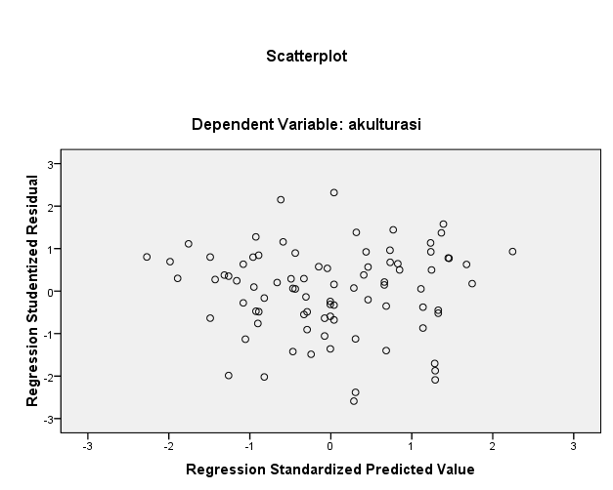
- Uji Linieritas

ANOVA Table
 |  |  | Sum of Squares | df | Mean Square | F | Sig.
akulturasi * hardines | Between Groups | (Combined) | 9075.046 | 34 | 266.913 | 1.295 | .200
 |  | Linearity | 1090.476 | 1 | 1090.476 | 5.289 | .026
 |  | Deviation from Linearity | 7984.570 | 33 | 241.957 | 1.174 | .299
 | Within Groups |  | 10308.131 | 50 | 206.163
 | Total |  | 19383.176 | 84

ANOVA Table
 |  |  | Sum of Squares | df | Mean Square | F | Sig.
akulturasi * dukungan sosial | Between Groups | (Combined) | 11234.712 | 38 | 295.650 | 1.669 | .049
 |  | Linearity | 1593.811 | 1 | 1593.811 | 8.997 | .004
 |  | Deviation from Linearity | 9640.901 | 37 | 260.565 | 1.471 | .107
 | Within Groups |  | 8148.464 | 46 | 177.141
 | Total |  | 19383.176 | 84

4.3.2 Uji Hipotesis
4.3.2.1 Uji Signifikansi Simultan (Uji F)

ANOVA^{b}
Model |  | Sum of Squares | df | Mean Square | F | Sig.
1 | Regression | 2227.678 | 2 | 1113.839 | 5.324 | .007ª
 | Residual | 17155.498 | 82 | 209.213
 | Total | 19383.176 | 84
a. Predictors: (Constant), dukungan sosial, hardiness
b. Dependent Variable: akulturasi

4.3.2.2 Uji Signifikansi Parsial (Uji t)

Coefficientsª
Model |  | Unstandardized Coefficients |  | Standardized Coefficients | t | Sig.
 |  | B | Std. Error | Beta
1 | (Constant) | 198.005 | 14.666 |  | 13.501 | .000
 | hardiness | -.246 | .142 | -.185 | -1.741 | .086
 | dukungan sosial | -.306 | .131 | -.248 | -2.331 | .022
a. Dependent Variable: akulturasi
4.3.2.3 Koefisien Determinasi (R2)

Model Summary
Model | R | R Square | Adjusted R Square | Std. Error of the Estimate
1 | .339ª | .115 | .093 | 14.464
- Predictors: (Constant), dukungan sosial, hardiness

- Sumbangan Efektif Tiap Peubah

Correlations
 |  | Y | XI | XII
Pearson Correlation | Y | 1.000 | -.237 | -.287
 | XI | -.237 | 1.000 | .211
 | XII | -.287 | .211 | 1.000
Sig. (1-tailed) | Y | . | .014 | .004
 | XI | .014 | . | .026
 | XII | .004 | .026 | .
N | Y | 85 | 85 | 85
 | XI | 85 | 85 | 85
 | XII | 85 | 85 | 85

Coefficientsª
Model |  | Unstandardized Coefficients |  | Standardized Coefficients | t | Sig.
 |  | B | Std. Error | Beta
1 | (Constant) | 198.005 | 14.666 |  | 13.501 | .000
 | XI | -.246 | .142 | -.185 | -1.741 | .086
 | XII | -.306 | .131 | -.248 | -2.331 | .022
a. Dependent Variable: Y

Model Summary
Model | R | R Square | Adjusted R Square | Std. Error of the Estimate
1 | .339ª | .115 | .093 | 14.464
a. Predictors: (Constant), XII, XI

