A Financial Simulation Model for Major University in the Middle East
Ahmed A. Bakhsh¹

¹Associate Professor, Dr. Ahmed Atef S. Bakhsh
Department of Industrial Engineering, Faculty of Engineering, King Abdulaziz University, Jeddah 21589, P.O. Box 80204, Saudi Arabia.
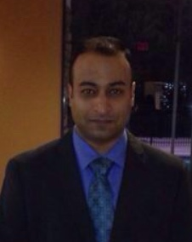
Tel: +966 (12) 6400000 Ext: 72417 (office)
Fax: +966 (12) 6952486
E-mail: aabakhsh@kau.edu.sa

AUTHOR PROFILE
Dr. Ahmed A. Bakhsh is an Associate Professor of Industrial Engineering at King Abdulaziz University in Jeddah, Saudi Arabia. He received B.S. and M.S. degrees in Industrial Engineering from King Abdulaziz University in Jeddah, Saudi Arabia. He also received an M.S. and Ph.D. degrees in Industrial Engineering from the University of Central Florida (UCF) in Orlando, FL. His research and teaching interests include Pareto analysis, stochastic objectives, cluster analysis, decision making analysis, object-oriented simulation, discrete event simulation, heuristic optimization, strategic management, and forecasting. He is a member of SIAM, IIE, ASQ, and SCS. His e-mail address is aabakhsh@kau.edu.sa.

